**Matrix** visual to show **Total Transactions**, **Total Revenue**, and **Return Rate** by **Product Name**(*on rows*)

* Add a visual level**Top N** filter to only show the top 10 product brands by Total Transactions

**New Card Visuals** to show **Total Transactions, Total Profit, Total Revenue and Return Rate**

**New Card Visual with Reference Labels** to build a card with **Total Revenue** filtered with **Latest start of month** and the metrics as follows: **Last Month Revenue, Revenue Target and Revenue Target Gap**

**New Card Visual with Reference Labels** to build a card with **Total Transactions** filtered with **Latest start of month** and the metrics as follows: **Last Month Transactions, Transaction Target and Transaction Target Gap**

**New Card Visual with Reference Label** to build a card with **Total Returns** filtered with **Latest start of month** and the metric **Last Month Return**

**Line Chart** coupled with a forecast and trend lineto show **Total Revenue** broken down by **year** and **Start of Month**

**Stacked Bar Chart** to break down **Total Transactions** by **Store Country**

**Report Interactions:** I wanted the **Stacked Bar Chart,** the **Monthly Revenue, Transactions and Returns** unfiltered based on the **Line Chart**

**Report Interactions:** I wanted the **Bar chart** unfiltered based on the **Matrix**

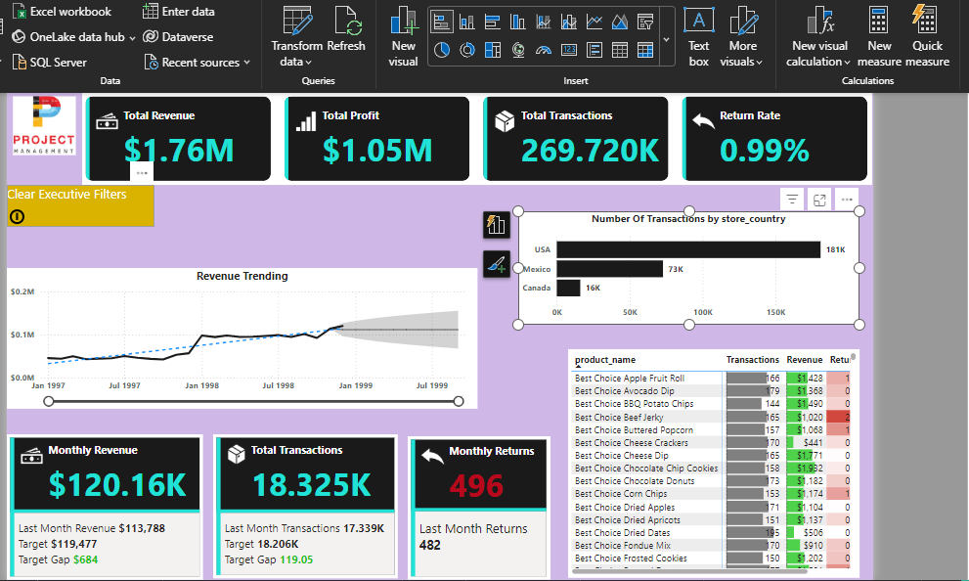

**Map** and relevant **Slicer** to show **Total Transactions** broken down by **Store Country**

